1623 NE 73rd Ave, Portland, OR 97213
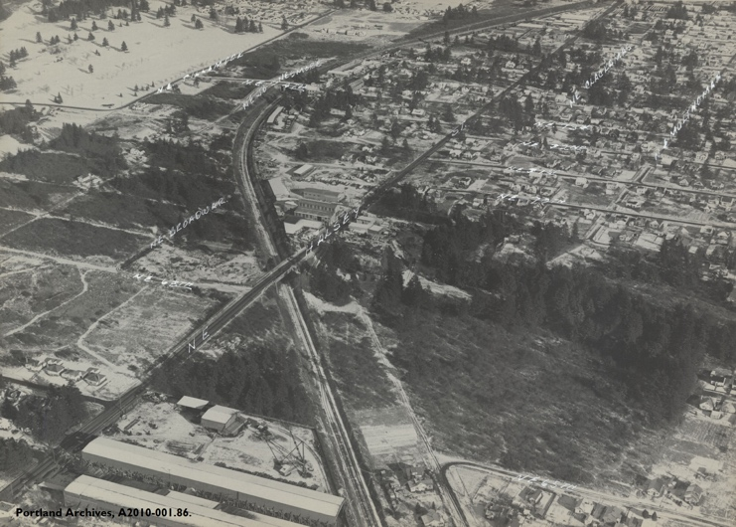
First known photo of the house

Timeline
- 1912 – House Built
  - address then was 369 E 73rd Ave N
- 1912 – Owned by M. J. Deveny
  - First information on the house is dated 2/2/12? for plumbing inspection for owner M. J. Deveny
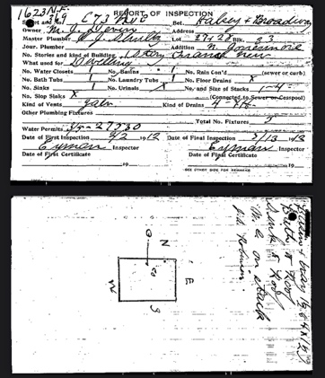
  - Appears to be built for Mr James Benjamin Deveny (1871-1945) & Wife Sophia Charlotte Deveny (Goodwin) (1872-1952) and family.
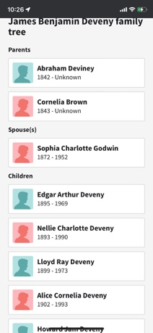

- 1939 – Plumbing Work Permitted. Changing from Cesspool to Sewer
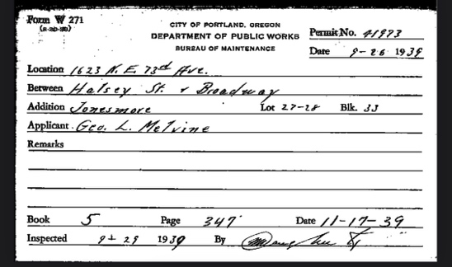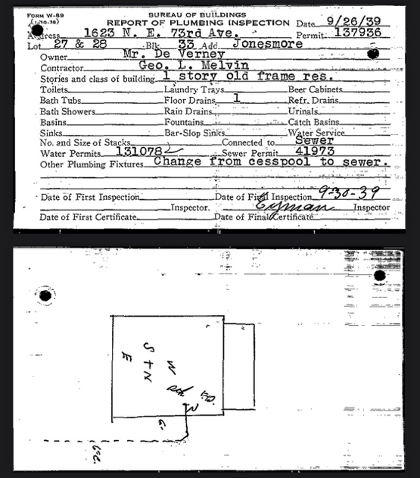

- Pre-1940 – According to 1940 Census, by 1940 ownership of the house had transferred to son Edgar Arthur Deveny (b. 1895(6)-d. 1969 m.1921) and wife Fern (1906-1986). At that time there were two children in the house (Irene & Nola (m. 1950)) are listed as residents.
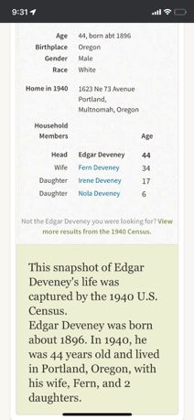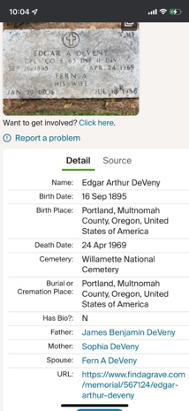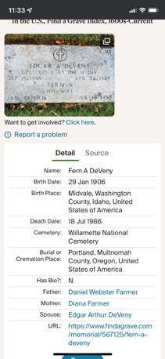

- 1947 – Plumbing inspection. Owners still Mrs Deveny (aka Fern) and Edgar.
    - 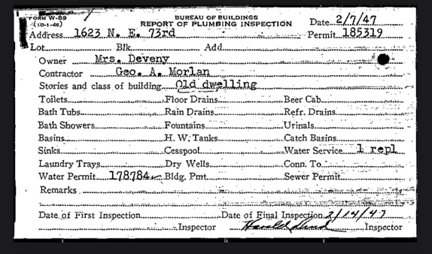

- 1966 – Permit for basement oil tank. Edgar (and Fern) are still the owners.
Note: I was told that the oil tank was removed sometime between 1992-1999 and given to the owners of 1611 NE 73rd (likely when the Gas Furnace was installed).
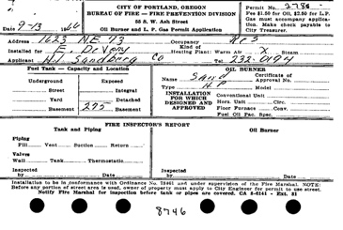

- 1969-1992 – Edgar died in 1969 and according to the next-door neighbor (who knew Fern), she died in the house 1986. Ownership likely transferred to Daughter Nola after Fern’s death and was certainly the owner of the house when it sold in 1992. According to the neighbor Nola (1933-2000) never moved back into the house with her husband Lloyd and daughter Diane and it is unknown who the occupants were with any certainty between 1986-1992.
Note: we were told that an old “crazy” lady lived here from the previous owners Randy & Christine. The neighbor confirmed that was fern and not a different tenant Fern than Nola who was married.
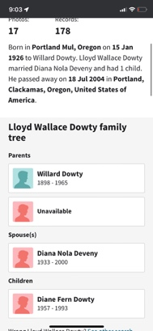

- Purchased by Wayne Irvin ET AL 12/1/1992 for $64,950 from Nola D Dowty (Maiden Name: Deveny)
  - Wayne Irwin ‘ET AL’ might have included Christine M Irvin since there doesn’t appear to be a transfer of ownership. I believe that Wayne is Christine’s dad.

- Purchased by Rodney A Young ET AL 5/1/1999 for $127,000 from Christine M Irvin

